# Assignment 4 Use Case

1. Spending Activity Management Application
   1. This app will add a history of money activities like spending and adding.
      1. 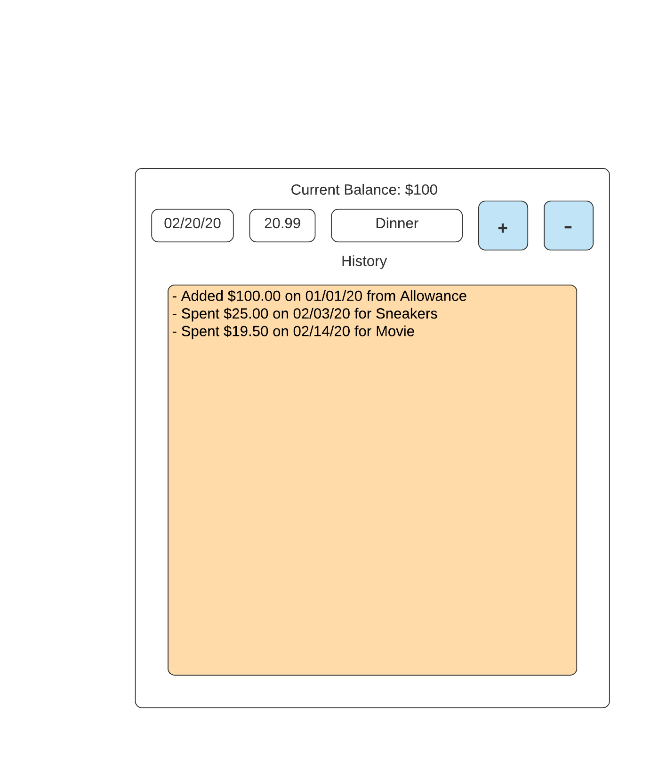As a I user I want to enter in the text boxes (1) the date, amount and activity

(1)

* + 1. Then I would click the **+** (2) or **-** button and it would save to the body (3) and update the balance (4) …

(4)

(3)

(2)